Dr.Surendra Kumar
MEANING OF MEASUREMENT OF ECONOMIC DEVELOPMENT
Economic development refers to economic growth accompanied by changes in output distribution and economic structure. These changes may include an improvement in the material well-being of the poorer half of the population; a decline in agriculture's share of GNP and a corresponding increase in the GNP share of industry and services; an increase in the education and skills of the labor force; and substantial technical advances originating within the country. As with children, growth involves a stress on quantitative measures (height or GNP), whereas development draws attention to changes in capacities (such as physical coordination and learning ability, or the economy's ability to adapt to shifts in tastes and technology).

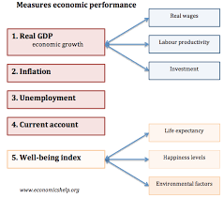

The extent to which a country has developed may be assessed by considering a range of narrow and broad indicators, including per capita income, life expectancy, education, and the extent of poverty.
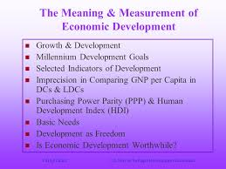

Different modes of measurement:-

GNP
Gross National Product (GNP) measures the economic output of a given nation. GNP can be used to measure the increase in real national income over a given period of time.
Criticisms of GNP
1. Real national income excludes price changes. A short period rise in national income during an upswing of an economic cycle does not constitute economic development.
2. GNP does not factor in a change in the population of a given nation.
3. GNP does not reveal or factor in the negative externalities such as pollution.
4. GNP tells nothing about the distribution of a societies income.
5. Does not factor in other forms of measurement such as illegal markets, services, etc.

PCRI
Per Capital Real Income (PCRI) is a measurement of income which also factors in population.
Criticisms of PCRI
1. PCRI Fails to measure changes in output due to changes in price lend.
2. Does not show whether any increase in income goes to the rich or the poor.
3. International comparisons of real GNP per capita are inaccurate due to exchange rate considerations of different currency's into one standard currency.
4. PCRI fails to take into account problems associated with basic needs like nutrition, health, sanitation, housing, education, etc.

PQLI
According to Morris D Morris: Physical Quality of Life Index (PQLI) is a measurement of the most basic needs of the people. It factors in a wide range of indicators such as health, education, water conditions, nutrition and sanitation.
PQLI is determined by taking 3 measurements,
1. Infant Mortality Rate (IMR) 2. Life Expectancy at age one 3. Literacy rate
and averaging these three factors giving equal value to each.
Criticisms
1. PQLI is a limited measure of basic needs
2. Many societal and psychological factors like security, justice, human rights, etc are excluded.
3. Does not explain the changing structure of economics and societal development.
4. Arbitrary weights are given to each determining factor.
5. PQLI does not measure economic development and total welfare.
6. There is no unanimity among the economists as to the number and type of items to be included in such an index.

HDI
the Human Development Index (HDI) is a quality of life index prepared by the United Nations Development Program. It is a composite index of life expectancy, adult literacy and years of schooling. It also considers P.C.I. (real)
HDI is a composit index of a long and healthy life, knowledge and a descent standard of living. Human development is the process of enlarging peoples choices and raising the level of well being.

